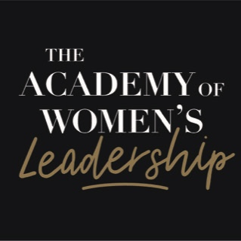

Module Workbook:
Planning your Physical, Intellectual and Emotional Health

Session outcomes:
- Supporting your physical, intellectual and emotional health
- Balancing your health so all areas are nourished
- Encouraging health in your teams and organisation

How is your physical wellness?

How intellectually stimulated are you?

How emotionally nourished are you?

What well are you and how committed to your own wellness are you?

How do you sustain your physical health through your diet, sleep and exercise routines?

How do you fuel your intellectual and creative health?

How do you sustain your emotional resilience and how well do you self-regulate your emotions?

What obstacles and barriers do you need to navigate to focus on your PIE health?

What support do you need to improve the quality of your PIE health?

What good habits do you have in place already?

What good habits can you establish and embed into your leadership to nourish your PIE health?

What activities will you add to your Intellectual Pick Mix?

How can you use coaching to support the emotional health of your colleagues?

Reflections on how Physical, Intellectual and Emotional Health in my leadership:

What do I commit to do as my next steps on my leadership journey?

